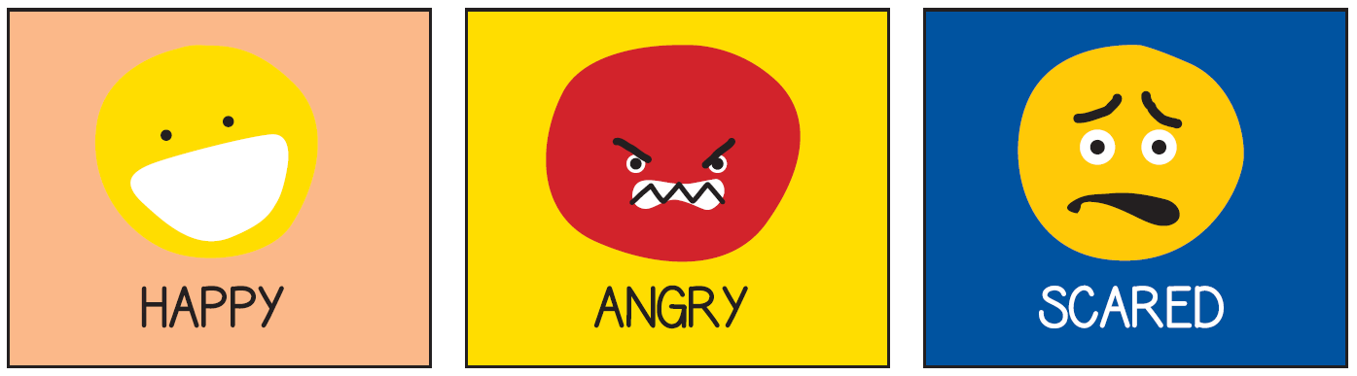
Use the cards to support talking about feelings and emotions.
A few suggestions:
Cut them out, turn them face down and then as you turn them over you give an example of when you might feel that emotion.
Draw a picture to match an emotion: It could be a scene or just a colour.
Create a dance. Does the angry dance look different from a happy one?
Think of a scene from a movie that matches each emotion e.g. scared – In Toy Story, Woody is scared when Andy is opening the birthday presents in case he gets replaced.

