Home Learning 21.7.21 – 23.7.21
ENGLISH
This is a series of lessons to introduce Holes by Louis Sacher.
This is a great book, so even if you don’t have time to complete all of the lessons, you may want to read the whole book over the holidays!

Here is the link to the lessons:
https://classroom.thenational.academy/units/holes-by-louis-sachar-3d8e
MATHS:
Follow the link to find the video for a Year 6 Bakery project:
https://whiterosemaths.com/homelearning/year-6/year-6-projects/
Stop the video at the time shown below to complete the activities. The activities are separate documents on the website.
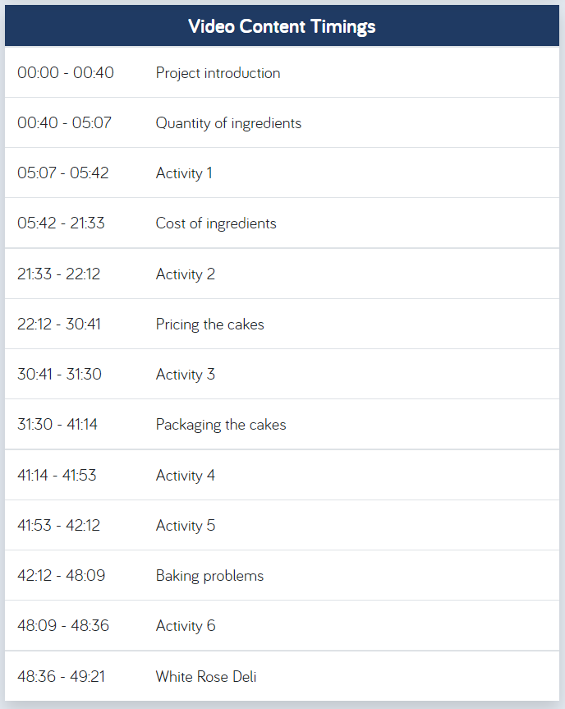
SCIENCE:
Evolution and Inheritance
Complete the activities on the following links:
- What is adaptation? https://www.bbc.co.uk/bitesize/topics/zvhhvcw/articles/zxg7y4j
- What is inheritance? https://www.bbc.co.uk/bitesize/topics/zvhhvcw/articles/zp9f4qt
- What is evolution? https://www.bbc.co.uk/bitesize/topics/zvhhvcw/articles/z9qs4qt
Watch the following videos:
- How animals survive in the desert: https://www.bbc.co.uk/bitesize/clips/zxcb4wx
- How are camels adapted to live in the desert? https://www.bbc.co.uk/bitesize/clips/z8fpyrd
- How cacti survive without water: https://www.bbc.co.uk/bitesize/clips/ztkc87h
- How fish are adapted to live in water: https://www.bbc.co.uk/bitesize/clips/zs2jmp3
- How have different animals adapted to their habitats? https://www.bbc.co.uk/bitesize/clips/zbp6n39
- Interdependence and adaptation: https://www.bbc.co.uk/bitesize/clips/z9gvr82
- Why does the giraffe have a long neck? https://www.bbc.co.uk/bitesize/clips/zwcg9j6
- Different adaptations between nocturnal and diurnal animals and birds: https://www.bbc.co.uk/bitesize/clips/zw62tfr
PROJECT:
Read through the PowerPoint on earthquakes.
ART:
Create a volcano collage in the style of Margaret Godfrey – see the PowerPoint on the website for more information.
DT:
Challenge: create a model of a volcano. Put a picture or video of it on Dojo for us to see!

