  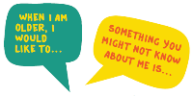    Monday | Who are you?  Scary… start with a blank piece of paper! Then you are going to build a picture of you. If you met someone for the first time what do they need to know about you? You could fold your paper into sections “I like”, “I don’t like”, “I am good at”.  Include your favourite songs, TV programmes, food, colours.  You can create a collage, draw pictures, write.. express yourself in any way you choose.
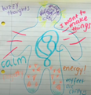  Tuesday | Draw your feelings  Watch the following video  https://www.youtube.com/watch?v=STdJ__8ORyE&feature=youtu.be  and draw your feelings. How do your legs feel? And your tummy? What about your head?  Use patterns and colours to express yourself.
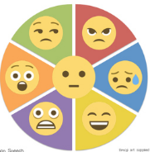  Wednesday | Express your emotions with your whole body  Watch the video clips and see how you can express emotion with your face and body. Play a game of emotion charades. What emotion am I expressing?  https://www.youtube.com/watch?v=eD9xCF22jKE movement though emotions  https://www.youtube.com/watch?v=m0R-ftFBm38 a more grown up version
  Thursday | Sing out!  What kind of music do you like? Rock, pop, hip hop?  Find your favourite song, learn the words and sing it out loud. If you don’t have a microphone, you can make your own or just use a wooden spoon or hairbrush.  Put on a show for your family if you feel confident! If you feel super confident send a video to your teacher
  Friday | Dress to Express  The idea is simple – use colour to express yourself by wearing a colourful outfit.  Wear it to school or on your Teams meeting. Send a picture of you in your colourful outfit to your year group email and we will create a display for when we return to school.


