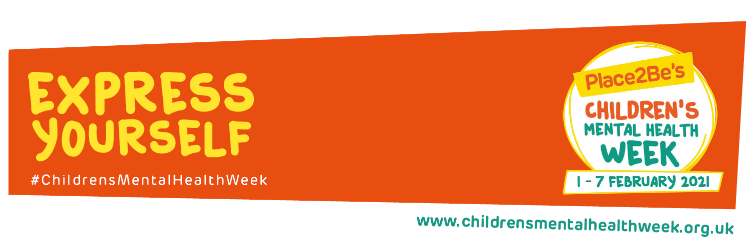

1st February 2021
Dear families,
With partial school closures, nationwide lockdown and a global wide pandemic, now is as important time as any, to consider not only our own mental health but the mental health of our children.
At Swanmore Primary School we offer a robust PSHE (Personal, Social and Health Education) curriculum for the children but this can be quite tricky to deliver through remote provision as there is often lots of class and group sharing involved.
We have been looking at ways to ensure that the children’s physical wellbeing is catered for through the Hampshire Games resources which go out each week. We recognise the link between physical health and mental health. There are lots of other physical challenges you can do – have a disco, go for a walk, play in the garden, do some Cosmic Yoga or Joe Wicks on YouTube.
This week we will launch our wellbeing campaign with the national children’s mental health week “Express Yourself”. The resources for this will be uploaded by your child’s year team.
We don’t want to make an assumption that every child is having worries or difficulties. Some children may be quite happy and content with lockdown, others may be bottling feelings up inside and some children may be quite angry or emotional. Instead, we will follow a “Toolkit” principle. We can fill our toolkit with ideas to help us out when we need them. We might not use these tools this week or this year! They may come in handy sometime in the future. This way we can ensure that children are able to express their feelings and emotions and have the tools in their toolkit to access when they need them!
So this week we will begin with the question: What is self-expression, and why is it important?
Self-expression is about communicating your individuality. This can be through words, clothing and hairstyle, or through art forms such as writing, drawing, music and dance. Self-expression can help you to showcase your true self – your story, your thoughts, feelings and emotions. But this can also make us feel vulnerable, so you might want to take things one step at a time. Self-expression is a great way to relieve yourself of stress and free your mind: to reflect on your life, actions, decisions, relationships, beliefs, and thoughts.
Week beginning the 8th February we will begin filling our toolkit with ideas sent out as part of your weekly planning.
If you have any worries or concerns, please communicate these with your class teacher or teaching assistant.
Best wishes and stay safe,
Mrs Hall

